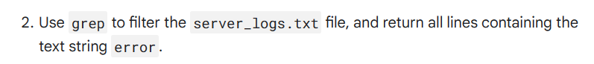

**Activity completed Using Linux bash shell**